BEAN SOUTH COFFEE

Brand Standards Manual
Tagline: Fresh Roasted in Americus, Georgia
Brand Essence: Authentic, handcrafted, and rooted in Southern tradition. Bean South Coffee embodies warmth, quality, and community through every cup.
Last Updated: January 2026
Document Owner: Bean South Coffee Team (Hugh, Vinnie, Geoffrey)
Next Review: Quarterly or with major brand updates

Table of Contents
- Brand Overview
- Logo Standards
- Color Standards
- Typography Standards
- Brand Voice and Messaging
- Visual and Photography Standards
- User Interface and Design Elements
- Packaging and Application Standards
- Website Implementation Standards
- Accessibility Standards
- Prohibited Uses
- Brand Compliance Checklist

1. Brand Overview
Bean South Coffee represents authentic, handcrafted coffee rooted in Southern tradition. The brand reflects warmth, craftsmanship, freshness, and community connection through every customer interaction and visual expression.
Core brand attributes:
Confident
Warm
Genuine
Authentic
Craft-focused
Community-rooted
All brand applications must reinforce freshness, local roots in Americus, Georgia, artisanal roasting, and product quality.

2. Logo Standards

Primary Logo
The primary logo is the black version displayed on light backgrounds.
This version should be used whenever possible.

Logo:
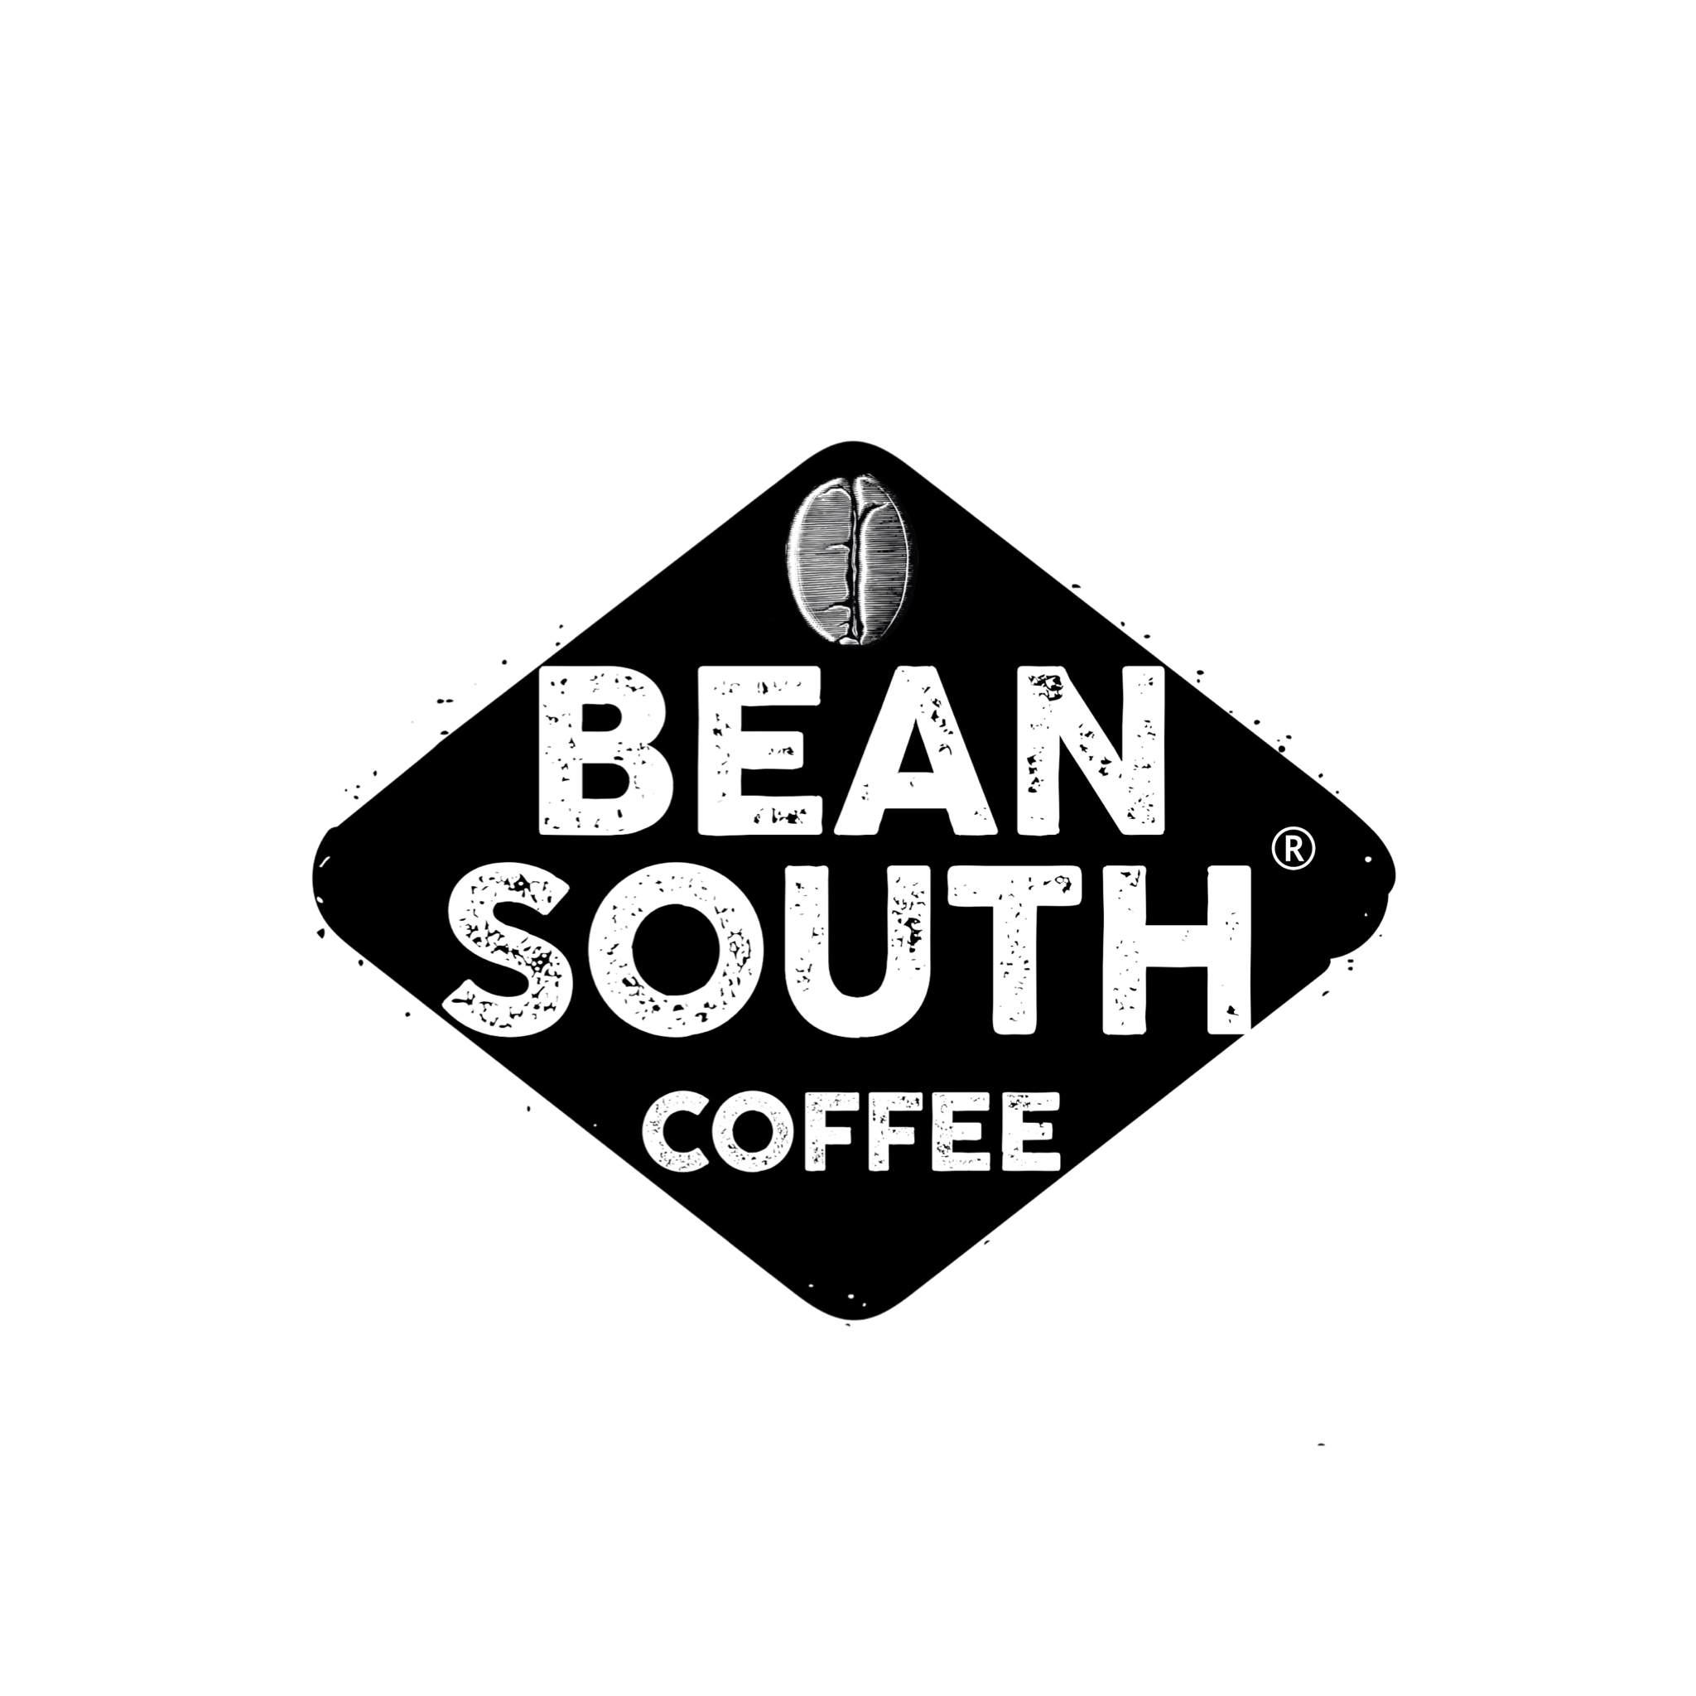

Approved Logo Versions
Approved versions include:
Black logo for light backgrounds
White logo for dark or tan backgrounds
Green logo for dark or tan backgrounds
No other logo color variations are permitted.

Logo Clear Space
A minimum clear space must be maintained around all sides of the logo.
The required clear space equals the height of the letter “B” in “Bean.”
No text, graphics, or other visual elements may enter this area.

Minimum Logo Size
Digital applications:
Minimum width: 120 pixels
Print applications:
Minimum width: 1 inch
The logo must remain legible at all sizes.

Acceptable Logo Usage
Permitted uses:
Maintain proportional scaling
Use only approved logo versions
Place on clean, solid backgrounds
Maintain sufficient contrast for readability

Prohibited Logo Usage
The following are not permitted:
Stretching or distorting the logo
Changing logo colors beyond approved versions
Adding effects including shadows, gradients, or outlines
Placing logo on busy or textured backgrounds
Using low-resolution files
Rotating or tilting the logo
Adding borders or outlines

3. Color Standards
The Bean South Coffee color system reflects coffee, natural materials, and Southern warmth.
Only the following colors may be used.

Primary Colors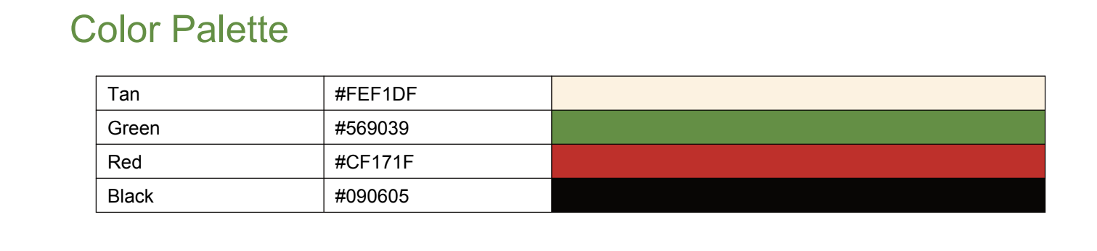
Coffee Brown
Hex: #4A3728
RGB: 74, 55, 40
Usage: Headers, primary text, logo
Tan / Burlap
Hex: #E8DCC4
RGB: 232, 220, 196
Usage: Backgrounds, sections, cards
Forest Green
Hex: #2D5016
RGB: 45, 80, 22
Usage: Buttons, links, highlights, calls-to-action

Secondary Colors
Cream / Off-White
Hex: #F5F1E8
RGB: 245, 241, 232
Usage: Alternate backgrounds and cards
Deep Red
Hex: #8B2E2E
RGB: 139, 46, 46
Usage: Sale pricing, urgency elements, special highlights
Black
Hex: #1A1A1A
RGB: 26, 26, 26
Usage: Body text, primary logo
White
Hex: #FFFFFF
RGB: 255, 255, 255
Usage: Text on dark backgrounds and negative space

Color Application Standards
Backgrounds:
Primary backgrounds must use Tan (#E8DCC4) or Cream (#F5F1E8)
Sections should alternate between tan and cream to establish hierarchy
Coffee Brown (#4A3728) may be used for dark sections sparingly
Text:
Body text must use Black (#1A1A1A) on light backgrounds
Headings must use Coffee Brown (#4A3728)
White may be used on dark backgrounds
Interactive Elements:
Primary calls-to-action use Forest Green (#2D5016)
Secondary calls-to-action use Coffee Brown (#4A3728)
Links use Forest Green (#2D5016)
Sale or urgency messaging uses Deep Red (#8B2E2E)

4. Typography Standards

Primary Brand Font (Print)
Cocogoose Pro – Letterpress
Used in:
Packaging
Logos
Print materials
This font represents the primary brand character in physical applications.

Web Font Standards
Because Cocogoose Pro may not be suitable for web, approved web fonts include:
Headings:
Primary: Montserrat
Alternatives: League Spartan, Poppins
Font stack:
Montserrat
League Spartan
Poppins
Sans-serif fallback

Body Text:
Primary fonts:
Poppins
Montserrat
Font stack:
Poppins
Montserrat
System sans-serif fallback

Typography Hierarchy
Headlines (H1, H2)
Font: Montserrat Bold (700)
Style: ALL CAPS or Title Case
Letter spacing: +0.05em when using all caps
Color: Coffee Brown (#4A3728)

Subheadings (H3, H4)
Font: Montserrat SemiBold (600)
Style: Title Case
Color: Coffee Brown (#4A3728) or Forest Green (#2D5016)

Body Text
Font: Poppins Regular (400) or Montserrat Regular (400)
Color: Black (#1A1A1A)
Line height: 1.6 to 1.8
Minimum size: 16px

Buttons and Calls-to-Action
Font: Montserrat Bold (700)
Style: ALL CAPS
Letter spacing: +0.1em
Size: 14px to 16px

Font Size Scale
H1: 40px–48px
H2: 32px–40px
H3: 24px–28px
H4: 20px–24px
Body: 16px
Small: 14px
Mobile sizes should be reduced by approximately 15–20%.

5. Brand Voice and Messaging

Voice Characteristics
Confident
Warm
Genuine

Tone
Approachable and professional
Friendly without excessive informality
Knowledgeable without pretension
Warm and welcoming
Southern charm combined with modern craftsmanship defines the tone.

Messaging Priorities
All messaging should emphasize:
Freshness
Local roots in Americus, Georgia
Handcrafted roasting process
Quality beans and roasting expertise
Community and local identity

Preferred Language
Freshly roasted
Handcrafted in small batches
Rooted in Southern tradition
Quality you can taste
From our roastery to your cup
Americus proud

Language to Avoid
Corporate jargon
Pretentious language
Overly technical terminology without context
Generic coffee clichés
Slang

Sample Messaging
Homepage headline:
Fresh Roasted Coffee from the Heart of Georgia
Product description example:
Rich, smooth, and full-bodied, our House Blend brings together the finest beans, roasted fresh daily in our Americus roastery.
Calls-to-action:
Shop Fresh Roasted Coffee
Discover Our Roasts
Taste the Difference
Order Fresh Coffee

6. Visual and Photography Standards

Subject Matter
Coffee brewing processes
Coffee beans
Roasting process
People enjoying coffee
Community coffee moments
Southern landscapes
Behind-the-scenes roasting

Photography Style
Lighting must be natural and warm
Images must appear authentic and documentary-style
Composition must remain clean and uncluttered
Color tones must remain warm and inviting

Photography to Avoid
Overly staged images
Harsh lighting
Cold lighting
Heavily filtered images
Generic stock imagery

Textures and Background Elements
Approved textures include:
Burlap
Wood grain
Coffee bean patterns
Paper textures
Textures must remain subtle and must never reduce readability.

7. User Interface and Design Elements

Layout Principles
Maintain generous white space
Use clear visual hierarchy
Use clean grid structures
Balance text and imagery
Guide visual focus intentionally

Buttons
Border radius: 4px to 8px
Primary button:
Forest Green background
White text
Secondary button:
Transparent background
Coffee Brown border and text
Hover state must darken color by 10–15%.

Cards
Background: Cream or White
Border: subtle tan border or shadow
Padding: generous spacing

Forms
Clean, minimal design
Borders in tan or light gray
Forest Green focus state
Labels positioned above inputs

Iconography
Style must be simple, geometric, and rustic
Line weight: consistent
Colors:
Coffee Brown
Forest Green

8. Packaging and Application Standards

Packaging
Base color: Tan (#E8DCC4)
Logo color: Black
Accent colors: Forest Green or Deep Red
Typography: Montserrat Bold for product names
Overall design must remain clean and minimal.

Examples:
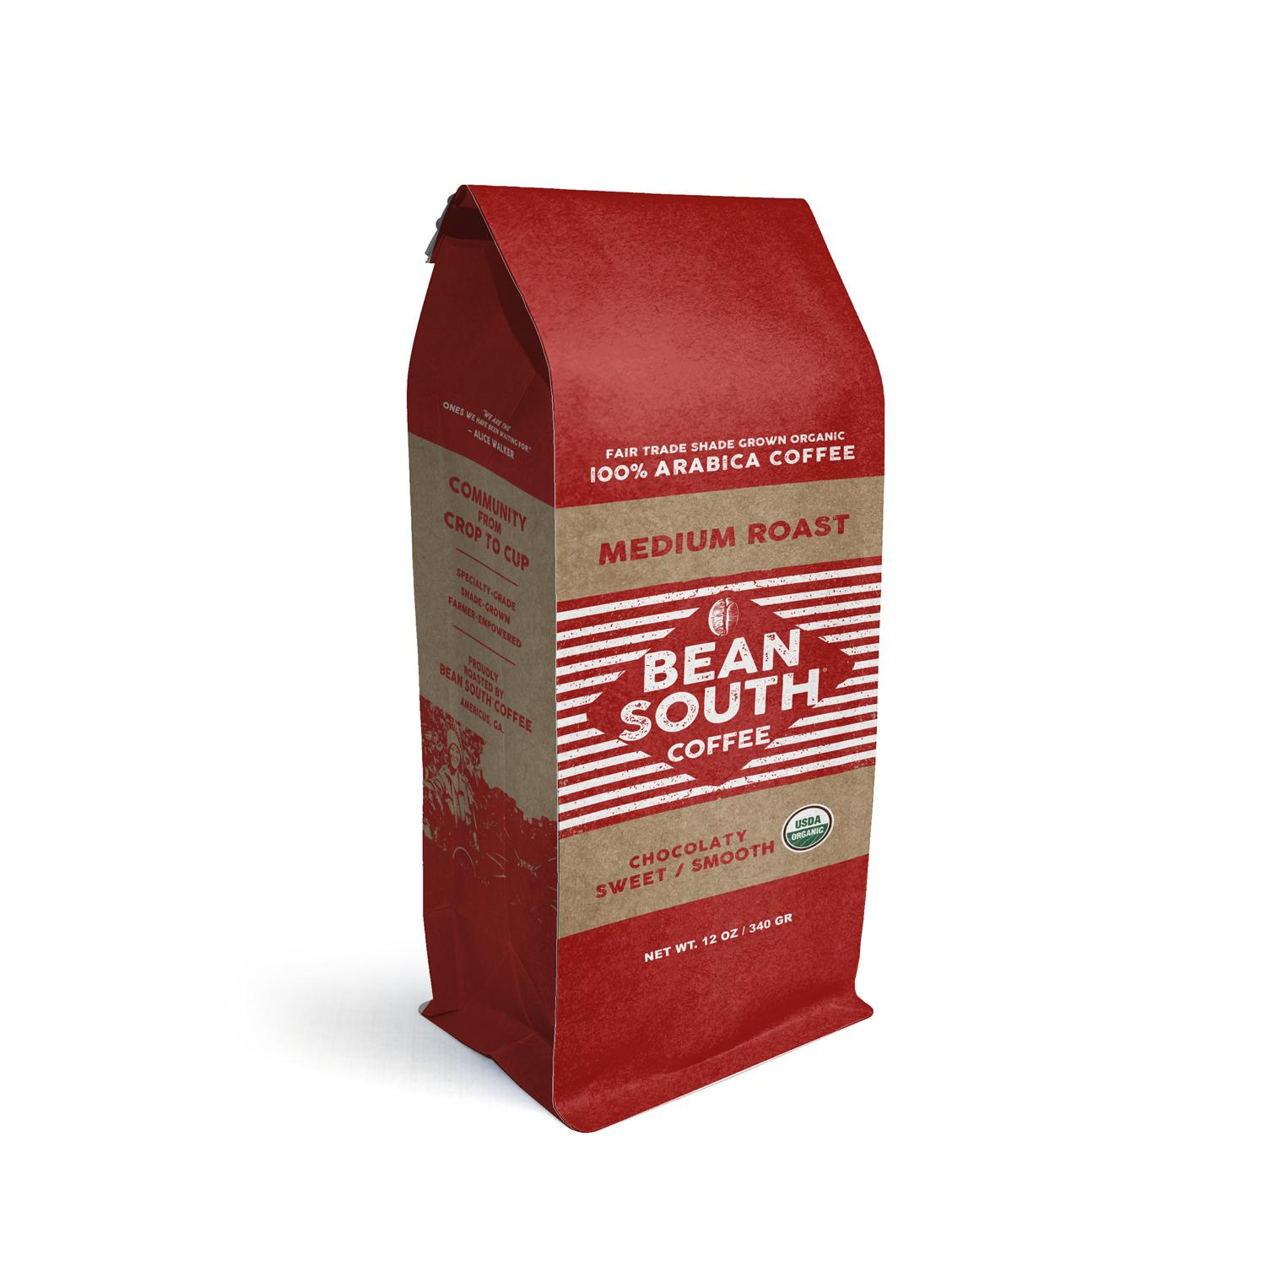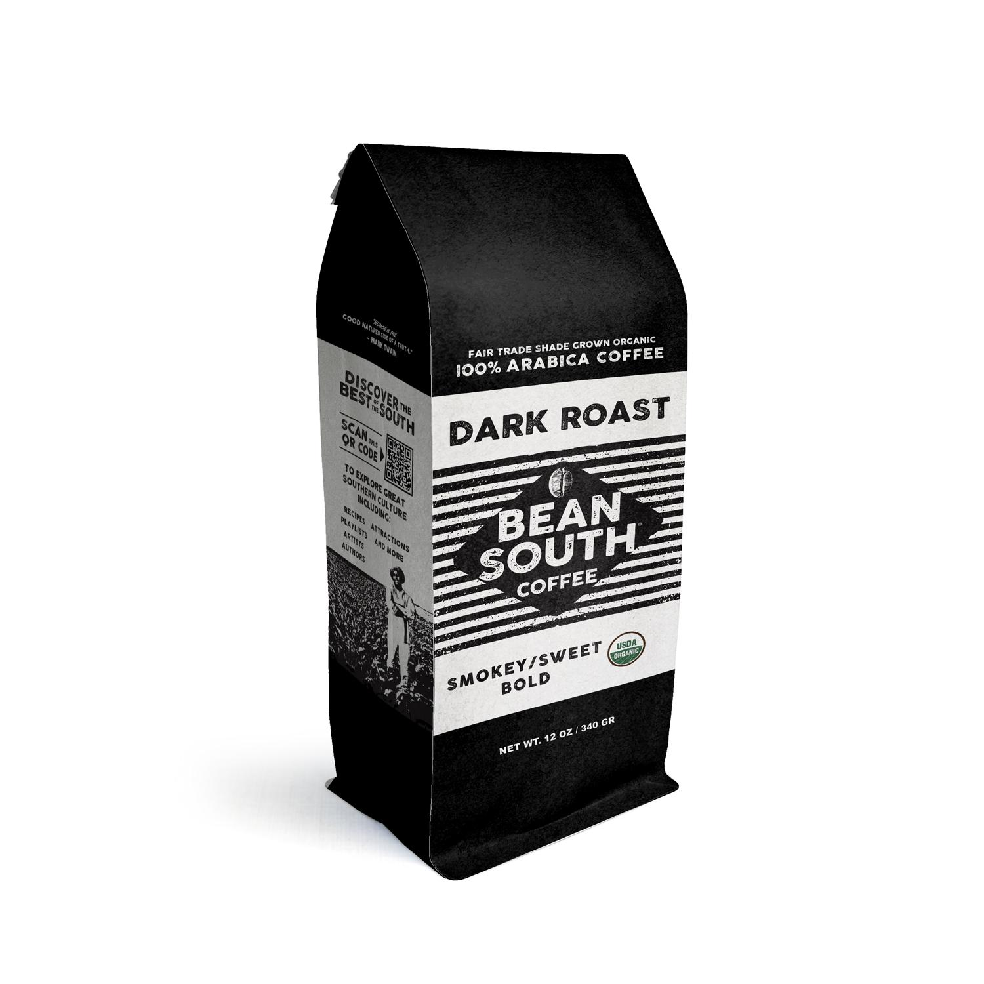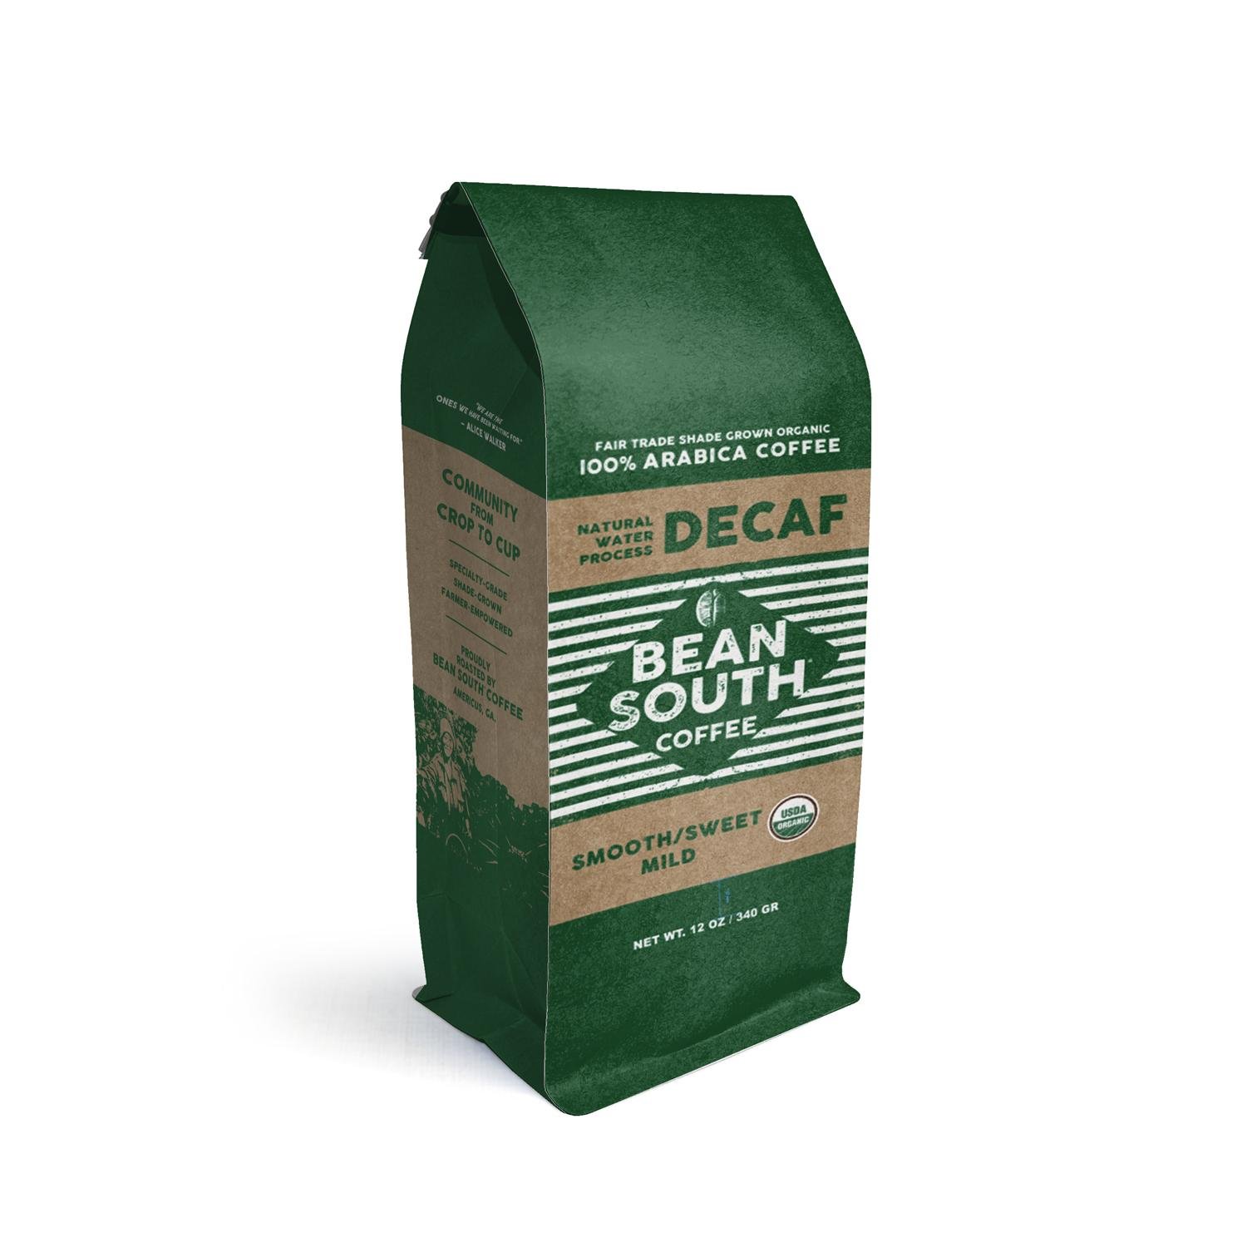

Website Applications
Homepage:
Tan and cream alternating backgrounds
Forest Green calls-to-action
Bold headline typography
Product pages:
Cream background
Clear product imagery
Forest Green add-to-cart buttons
Footer:
Coffee Brown background
White or cream text

Social Media
Use approved brand colors
Use warm image tones
Maintain consistent logo placement
Use storytelling imagery

Email
Tan header with black logo
White background body
Forest Green calls-to-action
Coffee Brown footer

9. Website Implementation Standards
Approved color variables:
Coffee Brown
Tan
Forest Green
Cream
Deep Red
Black
White
Approved font families:
Montserrat
Poppins
Headings must use Montserrat Bold.
Body text must use Poppins or Montserrat.

10. Accessibility Standards
All brand implementations must meet WCAG 2.2 Level AA contrast requirements:
4.5:1 minimum contrast for standard text
3:1 minimum contrast for large text
Body text must remain at least 16px.
All images must include descriptive alt text.
Buttons must remain clearly labeled.

11. Prohibited Uses
The following are strictly prohibited:
Using colors outside the approved palette
Using unapproved fonts
Using overly decorative fonts
Using neon or cold color palettes
Using generic stock photography
Overcrowding layouts
Applying heavy textures
Using corporate jargon or slang
Distorting logos
Changing logo colors
Applying visual effects to the logo

12. Brand Compliance Checklist
Before publishing any branded material, confirm:
Approved color palette used
Approved fonts used
Logo used correctly
Adequate white space maintained
Photography matches brand tone
Messaging reflects freshness and craftsmanship
Tone remains warm and professional
Accessibility requirements met

End of Brand Standards Manual

